**Sheraton Hotel Expansion**

Ryan Sheehan

11/30/2020

**Introduction**

Founded in 1937, Sheraton Hotels and Resorts is an international hospitality and leisure chain currently owned by Marriott International. It is one of the most well-known hotel chains across the world. The massive hotel corporation has over 400 hotels in over 80 countries world-wide. In 2019 alone the Marriott International team hosted over 1.5 billion international tourists. With such an extremely impressive resume companies of this size and influence are constantly looking for ways to grow to expand.

**Problem and Considerations**

For this project I assumed the role of a Data Scientist for Sheraton. The company is present in 42 out of the 50 states of America and is looking to add another to the list. The question is, where and why? The company wants to expand and open a new hotel but don’t know where to do it in order to accumulate the largest possible revenue from a new location. They want to grow their own brand regardless of whether a Marriott hotel is in the area or not. In order to make such an impact this new hotel not only needs to be in a state they have not yet set foot in but also needs to be somewhere that people actually want to stay. They need to know what city and where within this city they should be looking. In short, where could this building be constructed for the cheapest real estate prices and have the least amount of competitor hotels and motels to bid against for consumers?

**Data**

My sources of data that I will use for the project will be listed below.

1. Foursquare API will be used to locate venues across cities and generate detailed maps
2. Sheraton’s own website to find locations they are not present
3. Realtor.com to discover housing prices in the surrounding areas they decide to choose
4. Google Maps to locate points spread across the city due to lack of available data
5. ZipMap to determine zip code zones within the city of choice

**Methodology and Analysis**

My first steps in the project were finding out what states the hotel was not present in. The list was Mississippi, Nevada, Montana, Idaho, Wyoming, Vermont, Rhode Island, and Kentucky. Next in order to optimize the impact of this hotel I needed to find the most populated and visited cities within these states. They primarily came down to the capitals of each state except for Nevada, Kentucky, and Montana. I used the “folium” package to create visualizations of the cities. Once I found these prime areas for expansion I used the Foursquare API to generate calls for each city and see how many hotels were in each and find the cities with the least amount of hotel competition.

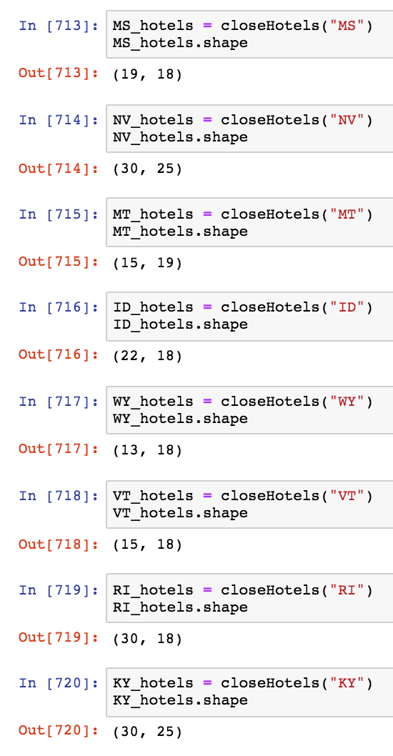

After seeing these values I determined a threshold of under 20 hotels would be the best opportunity for the new Sheraton. The next step was to decide between the 4 remaining cities. In order to this I used Foursquare API’s premium calls to get average ratings for all the hotels in each city and compare them.

Comparing these values resulted in the optimal city selection of Cheyenne, Wyoming. This city also coincidentally had the fewest number of hotels compared to other cities which is perfect for our decision-making.

For some reason Cheyenne was a very under mapped city. I found very little data regarding boroughs and neighborhoods within the city. Due to this limitation I used Google Maps to locate latitude and longitude points evenly spaced across the city. Then using each of these points, a radius of 10,000 meters, and a limit of 100 venues per spot I was able to get most if not all of the venues in the city of Cheyenne. I went through after concatenating all the queries and removed all duplicates in case the large radius overlapped for any areas. I then created a folium map to get my first glimpse at what this city’s layout was like.

From my own observation I could see a few groupings form in the data. To see if this was true I used the K-Means unsupervised clustering algorithm to find the clusters for me. Interestingly enough you can used latitude and longitude to group points on geospatial data.

From the elbow plot curve it appears the K-Means score increase begins to decline around 3 clusters so we will use 3 to group this data and represent it with a folium map of the new clusters.

These clusters seem to very well partitioned and are fairly evenly distributed. The groups and their associated colors were group 0 (blue), group 1 (green), and group 2 (red).

The next decision we need to make is which area to build this hotel within the city. People who visit cities and stay at hotels are usually there for tourism purposes. The ideal spot to put the new establishment would be a location near many enjoyable and fun activities so that the tenants would enjoy their stay as much as possible and maybe come back at a later time. Foursquare returned 256 unique types of venues within the city. This is far too much information to make our decision on. After consulting *Travel Wyoming* I was able to discover what the main attractions of Cheyenne are. Using this information I was able to deduce about 20 important factors for tourism within the city.

I then took a value count of these types of venues in each group made by the K-Means and compared them amongst each other.

After inspection it was clear that group 2 had by far the most amenities between the three groups. It was to be noted however that this area also had the most hotels. This increases the competition for the hotel but clearly there is a reason why they all chose the area of the city. With the average rating of 6.2 for the hotels across the city I still feel we stand a pretty good chance among the rest.

The next step was to decide where within this area would be the best location for our new establishment. This would require a comparison of pricing and a further breakdown of this area into smaller regions. As mentioned before geospatial data such as borough and neighborhood zoning was scarce if present at all. Due to this issue I split the group into zones depending on zip code. This was my own version of finding “neighborhoods”.

It was clear that zip code area 82001 had far more venues around and was more desirable. However if zip code 82007 were to be cheaper then Cheyenne’s public transportation services would allow tenants easy access of those venues it could be the better option.

I then did some research on Realtor.com to find median housing prices and median price per square foot in the city in order to finally discover which was best.

The Realtor.com listed neighborhoods we are most interested in are ‘Historic Cheyenne’ and ‘South Cheyenne’. Historic Cheyenne is zip code 82001 and South Cheyenne is zip code 82007. As seen from the graph the median house value in South Cheyenne is about $50,000 less than that of Historic Cheyenne. However the price per square foot in Historic Cheyenne is about $10 cheaper. Since hotels are historically large buildings and need a lot of square footage we are most likely going to be in the market for a lot or large building rather than a home. For this reason we would save much more money if we were to find a property in Historic Cheyenne rather than South Cheyenne.

Finally we need to see if there is a general area where all the hotels are located in Historic Cheyenne in order to possibly avoid some competition.

As we can see from the folium map western Cheyenne seems very densely populated with hotels. However the north near Randall Avenue or the east along East Lincolnway seems like a prime location for this new hotel. It is right near all the venues that ‘Historic Cheyenne’ has to offer and is even close to one of the other previous groupings. Putting a hotel in this centralized location would give all tenants the ability to access any part of Cheyenne they want and very easy access to major roadways to continue on road trips or maybe make the drive to Rocky Mountain National Park.

**Discussion**

Not only would Sheraton be able to expand its outreach to new customers and give existing ones a new experience, but it would also be able to capitalize on Wyoming’s blooming tourism economy. According to *Travel Wyoming* in 2018 the state saw 8.9 million overnight visitors throughout the year. The travel industry in Wyoming has seen steady spending increase since 2007 by an average of about 3.7% per year. The leisure and hospitality industry is also the largest private sector employer in the state! If Sheraton were to open a new hotel in the recommended area of Historic Cheyenne they would capitalize on the largest most visited city in this beautiful state which has a promising tourism economy. It seems as though the stars have aligned for this decision and the utilization of Foursquare API has only highlighted that very fact. If more available geospatial data were available further investigation would most likely bring forth different and interesting information regarding the various neighborhoods and boroughs. The neighborhoods and boroughs I was working with were all created by myself and the K-Means algorithm so little demographics were able to be pulled for each area.

**Conclusion**

Cheyenne, Wyoming is a busy city with beautiful views, an active nightlife, and a wonderful historic presence. The state has a growing tourism market that shows no signs of stopping. However, most importantly Sheraton is yet to cash in on this wonderful opportunity. With new clientele available and little competition in sight this seems like a decision you just can’t go wrong with.

The data and information gained in this report could also be used for someone trying to open any kind of a new venue in the city. Clearly the application of different filters for various venues would have to be applied but the general flow of work could be followed almost identically to find locations of low density venues and optimal financial costs.

**References**

[Foursquare](https://foursquare.com/) [1]

[Sheraton](https://sheraton.marriott.com/destinations/) [2]

[Google Maps](https://www.google.com/maps/place/Cheyenne,+WY/data=!4m2!3m1!1s0x876f38762e73ef93:0xb10a30418f972d2b?sa=X&ved=2ahUKEwi4jprxl6vtAhXHFFkFHVqdDU0Q8gEwAHoECAQQAQ) [3]

[Realtor.com](https://www.realtor.com/realestateandhomes-search/Cheyenne_WY/overview) [4]

[ZipMap](https://www.zipmap.net/Wyoming/Laramie_County/Cheyenne.htm) [5]